



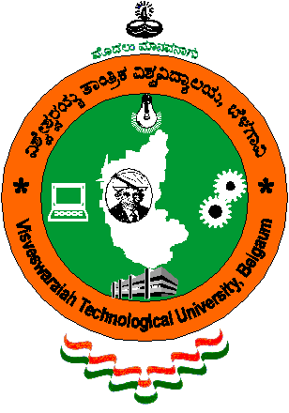
Visvesvaraya Technological University
BELGAUM, KARNATAKA

A PROJECT REPORT
ON
“Student Attendance System Using IOT”

Submitted to Visvesvaraya Technological University in partial fulfillment of the requirement for the award of Bachelor of Engineering degree in Computer Science and Engineering.

Submitted by
Name USN
STUTI ADARSH 4JN14CS106
SAPTAHMI G PRABHU 4JN14CS090
GAUTHAMI N 4JN14CS126
PAVITRA G REVANKAR 4JN14CS068

Under the guidance of
Mr. Narendra Kumar S _{B.E.,M.Tech.}
Asst. Professor, Dept. of CS & E,
JNNCE, Shimoga.
Department of Computer Science & Engineering
Jawaharlal Nehru National College of Engineering
Shimoga - 577 204

JUNE 2018
